
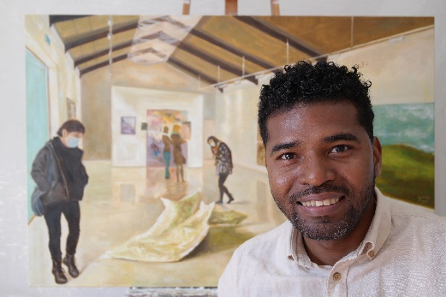
Rayder Balsinde (Raybal)

Rainstrasse 21, 2503 Bienne
079’ 317 37 39
To consult my works
rayder.balsinde3@gmail.com
Divorced, a daughter (secured custody)
Permis C, Cuban

*** Trajectory ***

From 2001 until 2009, I took drawing and painting courses at the Workshop of The Municipal House of Culture in Santiago de Cuba.

In parallel, from 2004 until 2010, I followed Socio-Cultural studies at The Oriente University in Santiago de Cuba. During this time, I have won various prizes (" Premios de Oro") for drawings and paintings I have made.

In 2007, I took ceramics classes at the Atelier Luis Diaz Oduardo, in Santiago de Cuba.

Since November 2022, I have been a professor of drawing and painting at The Popular University of Bienne.

***
The VIVENCIAS series shows everyday life through contemporary realism. It reflects the human figure, perspective, urban landscapes, interior painting and other...

The works are made with oil on canvas in the Alla-Prima style (“wet on wet painting"), seeking the play of lights and shadows. Without further delay, you are invited to delight in this pictorial-magic universe that leads us to visual pleasure.

*** Exhibitions ***

Personal exhibitions

2023 Vivencias, Local Römerquelle, Bienne

2022 Vivencias, ArtyShow, Biel/Bienne

2019 Cuba, Cityscapes, Artyshow Biel/Bienne

2018 FACHADAS, A part of Cuba, Bürgerspital Solothurn

2016 Always on time, Kursaal, Bern

2015 FACHADAS, Arthur Gallery, Bienne

2014 FACHADAS, Meyer and Kangangi Gallery, Bien, Switzerland

2010 FACHADAS, Provincial Centre of Houses of Culture, Santiago de Cuba, Cuba.

Group exhibitions

2024 Participation in the Expo Cubanizado, Löwengalerie, Luzern

2023 Participation in the Cubart Festival, Löwengalerie Luzern, CubaNow Zürich, Fond. UDG, Puidoux, Kunstgarage Flawil

2022 Participation in the International Graphic Exchange Expo, MA. Martin Studio, Biel/Bienne

2021 Participation in the International Exhibition Cultural Course, Galerie Dispo, Nidau

2020 Participation in the Known and Unknown Expo, Maybaus Gallery, Erlach

2019 Participation in the Expo Dispo/Lake-Live, Nidau

2019 Participation in the Small Formats Expo, Place Suisse des Arts, Lausanne

2018 Participation in the Black Panthers Expo, Popup Galerie am Dreieck,
Ostermundigen

2018 Participation in the Plein Air Expo Kunst am See, Burgäschisee

2018 Participation in the Expo The flavour of mango and the colour of orange, Peripherie Bern

2018 Participation in the International Exhibition of Contemporary Art, Place Suisse des Arts, Lausanne

2016 Participation in the LAND ART project, Bienne

2016 Participation in Place à L'art, Centre de culture et loisirs, Saint-Imier

2015 Participation in the LAND ART project, Bienne

2015 Participation in the exhibition Aquarelle'15, Place Suisse des Arts, Lausanne

2015 Participation in the exhibition of the habitARTE gallery, Bern

2015 Participation in the winter exhibition of the habitARTE gallery, Bienne

2014 Participation in Place à l'Art, Centre de culture et loisirs, Saint-Imier

2010 Participation in the International Meeting of Internal Wall Painting, Santiago de Cuba

2009 Unfinished dreams with the group Art-JO, Santiago de Cuba

2007 The sap of the trees with the Proyecto Huracan, Santiago de Cuba.

*** Prizes and distinctions ***

2015 Recognition Prize in the 100th anniversary competition of Caran d'Ache, Master category

2008 Awarded at the Provincial FEU Festival (University Students' Federation), Santiago de Cuba

2008 Awarded at the Municipal FEU Festival, Santiago de Cuba

2007 Awarded at the Provincial FEU Festival, Santiago de Cuba

2006 Awarded at the Municipal Drawing Fair, Santiago de Cuba

2005 Awarded at the Provincial Painting Exhibition, Santiago de Cuba

2004 Awarded at the Municipal Painting Fair, Santiago de Cuba

2003 Awarded at the Municipal Drawing Fair, Cuba

2002 Awarded at the Municipal Drawing Fair, Santiago de Cuba.

